Video Lesson 1: Disney

*Have a look at the videos and answer the questions online. Fill in your scores.*

*This is where you can see your score*

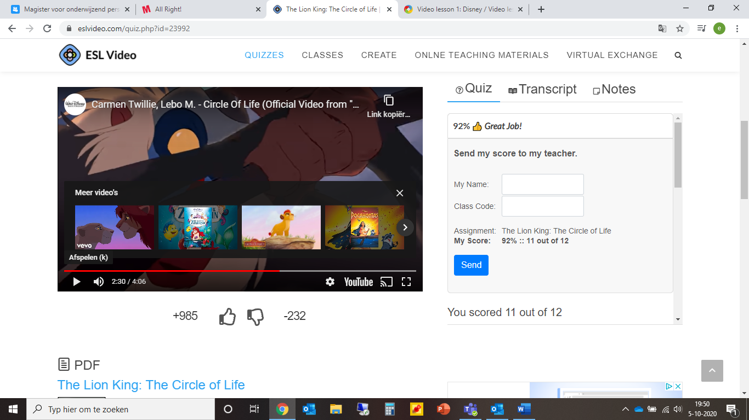

1. The lion King

You scored …………………….. out of ………………………………

1. Minions

You scored …………………….. out of ………………………………

1. Sesame street

You scored …………………….. out of ………………………………